Sustainable Preservation and Promotion of Heritage: The Virtual Museum

AVICOM Annual Conference & f@imp Festival 2023 – St Andrews, Scotland
Preliminary Program Version August 14 (All times: GMT)
Thursday September 21 Arrival Day:

15:00 Optional: Visit to the Wardlaw Museum (Museum of the University of St Andrews)

17:00 Medieval St Andrews guided tour (including St Andrews cathedral and castle)
Meeting point: Entrance to the Wardlaw Museum

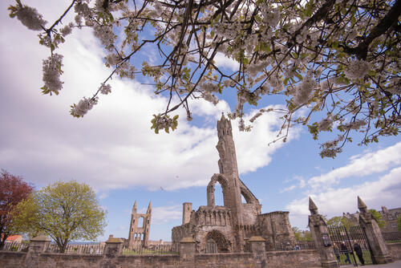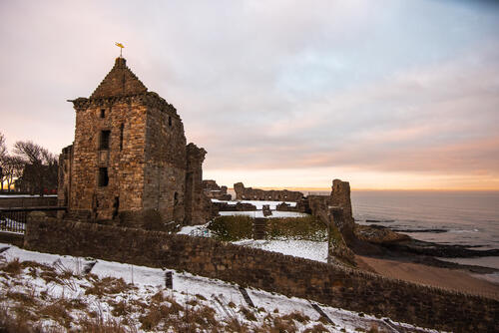

19:00 Welcome Meeting, School of Computer Science of the University of St Andrews, Jack Cole Building, North Haugh, St Andrews

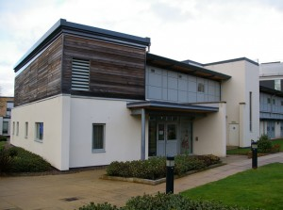

Friday September 22: Sustainable Preservation and Promotion of Heritage: The Virtual Museum. General Assembly and Conference Part 1
Parliament Hall of the University of St Andrews, 66 South St, St Andrews

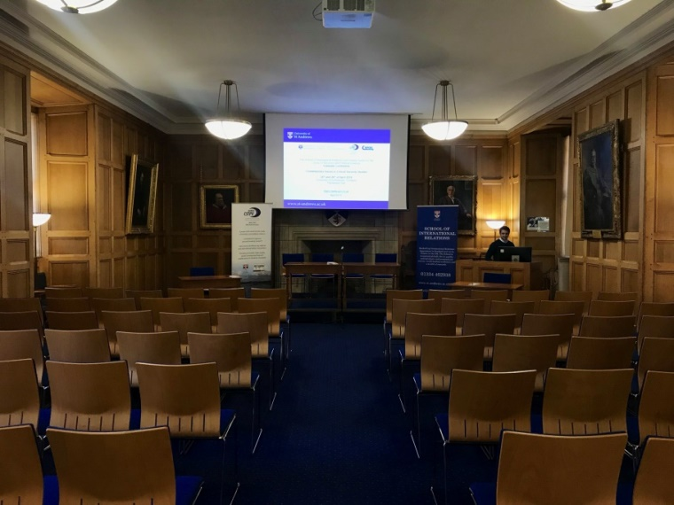

9:30 – 10:00 Registration

10:00 – 10:15 Opening
N.N. (Representative of St Andrews)
Alan Miller, University of St Andrews
Michael H. Faber, Chair of AVICOM

Questions of Principle and Basics

Moderation: Janos Tari, Károli Gaspár University Budapest, Hungary / Ex Chair of AVICOM

10:15 – 10:35 Gaoli Liu, National Ainu Museum, Shiraoi Hokkaido, Japan:
Exploring the Advantages and Challenges of Virtual Museums: A Case Study of the National Ainu Museum

10:35 – 10:55 ONLINE: Kathryn Nellis Medill-Torres, Rocky Mountain College of Art and Design, Denver Colorado, USA:
An Anecdotal Review of the Guiding Questions for AVICOM’s General Assembly Conference 2023

10:55 – 11:55 WORKSHOP: Alan Miller, Kamila Oles, Open Virtual Worlds Research Group, School of Computer Science, University of St Andrews, Scotland, U.K.; Julia Römhild, Bernd Günter, Faculty of Business Administration and Economics, Heinrich-Heine- Universität Düsseldorf, Germany:
Under Construction: Defining Virtual Museums in the context of Sustainablility

Methodical Approaches

Moderation: N.N.

11:55 – 12:15 Simina Badica, House of European History, Brussels, Belgium:
How to create a virtual European History experience?

12:15 – 12:30 Discussion

12:30 – 14:00 Lunch (Self-paying)

14:00 – 14:20 Can Chen, Bournemouth University, Poole, U.K.:
Media Arts in Narrative-style Exhibition : Curatorial Approaches in China

14:20 – 14:40 Rasa Bocyte, Max Tiel, Netherlands Institute for Sound & Vision, Hilversum, The Netherlands; Arno Verhofstadt, Wendy Van den Broeck, Vrije Universiteit Brussels, Belgium:
Remotely Together: The Virtues and Limitations of Social XR in the Cultural Heritage Sector

Attracting Visitors, Barrier Reduction and Sustainability

Moderation: N.N.

14:40 – 15:00 Hazem Mohammed Farrag, Tourist Guidance & Heritage Management, Faculty of Arts, Ain Shams University, Cairo, Egypt:
Exploring the Perspectives and Expectations of Egyptian Tour Guides on the Incorporation of Virtual Museum Tours in Tourism Activities: Implications for Enhanced Tourist Engagement

15:00 – 15:20 Rema Zeynalova, Azerbaijan National Carpet Museum, Baku, Azerbaijan:
Breaking boundries at the Azerbaijan National Carpet Museum: Virtual Museum as a tool for increasing accessibility

15:20 – 15:40 Funda Yüksel Özer, Mersin Arkkeoloji Müzesi, Yenişehir Mersin, Turkey:
New Approach to Virtual Museum

15:40 – 16:00 Julia Römhild, Bernd Günter, Faculty of Business Administration and Economics, Heinrich-Heine-Universität Düsseldorf, Germany:
Unveiling the Potential: Virtual Museums for Sustainable Development

16:00 – 16:30 Break

16:30 – 16:50 Kamila Oles, Alan Miller, Open Virtual Worlds Research Group, School of Computer Science, University of St Andrews, Scotland, U.K.:
Promoting Sustainable Development with Emergent Immersive and Mobile Technologies

16:50 – 17:00 Discussion

Practical Examples / Case Studies

Moderation: N.N.

17:00 – 17:20 Eva Schubert, Museum With No Frontiers (MWNF), Vienna, Austria
The transnational Museum With No Frontiers programme – online collections, exhibitions, galleries, tours – and hosting the largest online resource dedicated to the artistic legacy of Islam

17:20 – 17:40 Mohamed Ismail Ibrahim, Faculty of Archaeology, Ain Shams University, Cairo, Egypt:
Building a Virtual Museum within a Museum: The Zafaran Museum as an Example

17:40 – 18:00 Angelina Hayryan, Sergey Parajanov Museum, Jerewan, Armenia:
The virtual museum as a unique approach to contemporary arts

18:00 – 18:20 Lara Corona, Universitat Internacional de Catalunya, Barcelona, Spain
Virtual museums: a threat for ‘real museums’ or an additional value to them?

18:20 – 18:30 Discussion

19:00 Meeting in a traditional Pub (precise location details to be communicated later)

Saturday September 23: Sustainable Preservation and Promotion of Heritage: The Virtual Museum. General Assembly and Conference Part 2
Parliament Hall of the University of St Andrews, 66 South St, St Andrews

Practical Examples / Case Studies

Moderation: N.N.

9:30 – 9:50 Muhammad Zubair Rabbani, Bahawalpur Museum, Bahawalpur, Pakistan:
Virtual Museums: A Gateway to Cultural Exploration

9:50 – 10:00 Yuqiao Hu, School of Museum Studies, University of Leicester, U.K.:
Empowering Small Museums in Creating Virtual Museums on Social Media Platforms - A Case Study of Longxi County Museum, China

10:10 – 10:30 Nina Pearlman, Andy-Hudson Smith, Valerio Signorelli, Leah Lovett, Jason McEwan, UCL Museums, UCL, London, U.K.:
Bridging Worlds: Novel panoramic capture and virtual navigation of exhibition spaces at UCL

10:30 – 10:50 Kaji Appolinaire, Musée La Blacktude, Yaoundé, Cameroon:
Virtual exhibition on traditional African musical instruments: Issues and audiences

10:50 – 11:00 Kamila Oles, Alan Miller, Open Virtual Worlds Research Group, School of Computer Science, University of St Andrews, Scotland, U.K.:
Climate Change and the Virtual Museum

11:00-11:10 Kamila Oles, Alan Miller, Open Virtual Worlds Research Group, School of Computer Science, University of St Andrews, Scotland, U.K.:
The digital curation of open-air museum Augmented Reality (AR) and Virtual Reality (VR) mobile apps

11:10 – 11:20 Discussion

11:20 – 11:35 Short Coffee Break („1 coffee“)

11:35 – 12:00 ONLINE: Nicolle Manuelle Bahia Bittencourt, Graduate School of Asia-Pacific Studies
Waseda University, Tokyo, Japan:
From physical to virtual: Information and Communication Technologies Strategies adopted by the National Museum of Brazil and Shurijo Castle in Japan after a destructive fire

Discussion

12:00 – 12:15 Michael H. Faber, Chair of AVICOM
Conclusions. Results of the Conference

12:15 – 12:45 General Assembly of AVICOM (for AVICOM members only)

12:45 – 14:00 Lunch (Self-paying)

14:00 – 15:30 Faimp Award Ceremony

15:40 Assembling at the designated bus for the trip to Dundee (specific location details to follow).

16:15 – 18:00 Guided exploration of Discovery Point and RRS Discovery in Dundee, located along Riverside Drive.
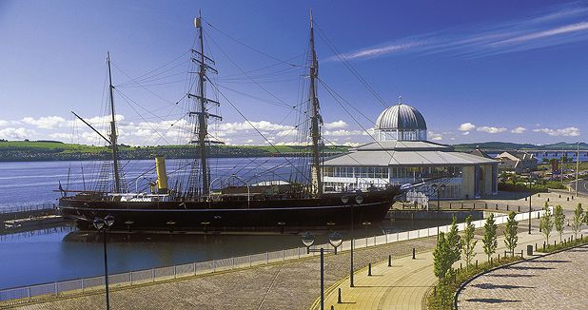

19:00 Conference Dinner with Reception of the Faimp Winners at Discovery Point, Dundee
(Self-paying by participants; Winners: free)
(Meeting point will be announced later.)

Sunday Sept 24 Departure Day

10:00 Gathering at the School of Computer Science, University of St. Andrews, situated within the Jack Cole Building on North Haugh, St. Andrews. Luggage storage is available at this location, in room no 0.37. Refreshments, including coffee and tea, are provided.

